Image to PDF using Zen Reports

Zen report can create PDF document (https://docs.intersystems.com/latest/csp/docbook/DocBook.UI.Page.cls?KEY=GRPT_xslfo_pdf_config ). Store your image name in the table. Pass session id to the Zen report. Zen report will select images using SQL. The <img> element will insert images to the report:
<img width="100%" src="!@ImageName" contentHeight="scale-to-fit" contentWidth="#(..ImageWidth)#" style="position:absolute" content-type="image/jpg"/>
 | Management portal: Zen Report settings: Select System Administration – Configuration – Zen Reports – Settings  Note! Make sure Adobe reader is installed | 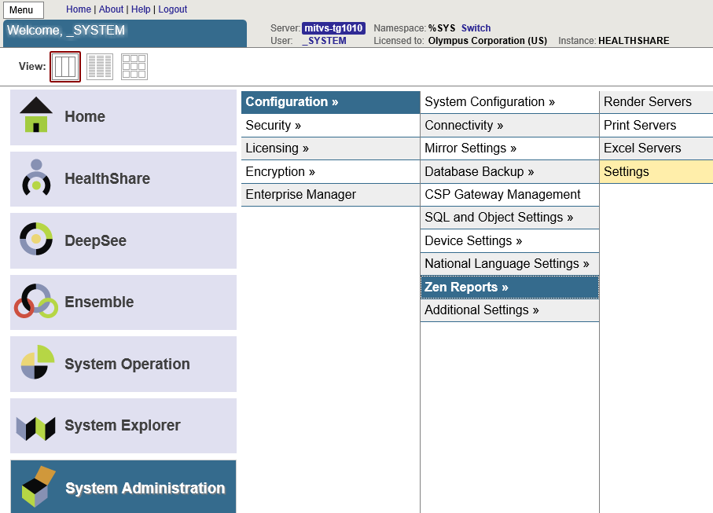
 | Select Adobe Path for Pdfprint. Click Save | 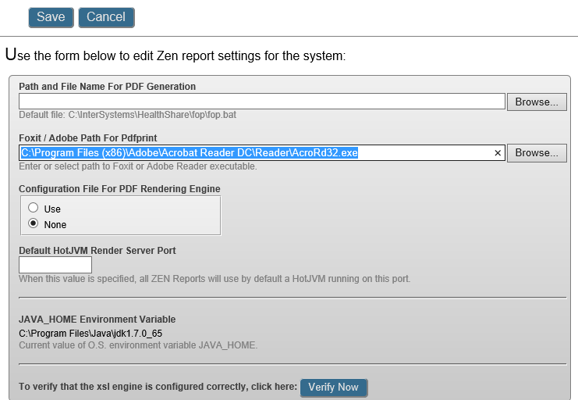
Store Image name in the Table:
Class Training.Tbl.ZenImageTable Extends (%Persistent, %XML.Adaptor)
{
Property SessionId As %String;
Property ImageName As %String(MAXLEN = "");
Property DateCreated As %TimeStamp [ InitialExpression = {$ZDateTime($H,3)} ];
}
 | Copy image files under /CSP/HealthShare/Namespace/ (“\CSP\healthshare\training\ZenImages”)
Create Zen PDF report:
Class Training.Zen.ZenImageToPDF Extends %ZEN.Report.reportPage
{
// 6 or 12 only.
Property ImagesPerPage As %Integer [ InitialExpression = 6 ];
// "2in" 12 images per page; "2.4in" for 6 images per page
Property ImageWidth As %String [ InitialExpression = "2in" ];
// "3" for 12 images per page; "2" for 6 images per page
Property ImageColumns As %String [ InitialExpression = "3" ];
// HealthSahre Web server port
Property HSPort As %String [ InitialExpression = "80" ];
/// Class name of application this report belongs to.
Parameter APPLICATION;
Parameter XSLTVERSION = 2.0;
Parameter URL = "pdf";
Parameter DEFAULTMODE = "pdf";
Property arHeader As array Of %String;
Property ReportSessionId As %String(ZENURL = "ReportId");
Property BaseUrl As %String(ZENURL = "BaseUrl");
/// This is the optional XML namespace used for the report.
/// ReportDefinition is a placeholder.
XData ReportDefinition [ XMLNamespace = "http://www.intersystems.com/zen/report/definition" ]
{
<report xmlns="http://www.intersystems.com/zen/report/definition"
name="MyReport"
sql="SELECT ImageName,SessionId FROM Training_Tbl.ZenImageTable WHERE SessionId = ?" >
<parameter expression="..ReportSessionId"/>
<attribute name="RunDate" expression='$ZDATE($HOROLOG)'/>
<!--<call method="SetImagesPerPage"/>-->
<group name="SessionId">
<attribute name="ImageName" field="ImageName" expression="..GetDisplayUrl(%val)" />
<!--<attribute name="ImageName" field="ImageName" />-->
</group>
</report>
}
XData ReportDisplay [ XMLNamespace = "http://www.intersystems.com/zen/report/display" ]
{
<report xmlns="http://www.intersystems.com/zen/report/display" name="MyReport" >
<init>
</init>
<document
width="8.5in"
height="11in"
marginLeft="1in"
marginRight="1in"
marginTop="0.5in"
marginBottom="0.5in"
footerHeight="0.5in"
headerHeight="0.5in"
regionAfterExtent="0.25in"
regionAfterColor="white"
regionBeforeExtent="0.25in"
regionBeforeColor="white"
orientation="portrait" >
<class name="table.myTable">
<att name="column-count" value="2" />
</class>
</document>
<pageheader >
<table orient="row" ongetData="GetPageHeader" layout="auto"
style="border:0.5pt solid black;font-size:7;" rowAcrossPages="false">
<parameter value="Header"/>
<item style="text-align:left" fieldnum="1" suppressEmpty="true">
<!--<caption style="text-align:left" value="PatientID"/> -->
</item>
<item style="text-align:left" fieldnum="2" suppressEmpty="true">
<!--<caption style="text-align:left" value="Patient"/> -->
</item>
<item style="text-align:left" fieldnum="3" suppressEmpty="true">
</item>
</table>
<line pattern="solid" thickness="0.25px"
color="black" width="7.5in"/>
</pageheader>
<!-- Optional Pagefooter element. Does not apply in HTML output. -->
<pagefooter >
<line pattern="solid" thickness="1px"
color="black" width="7.5in"/>
<table orient="row" style="padding-right:0;">
<item style="text-align:left" special="page-number-of" width="2in">
<caption style="text-align:right" value="Page "/>
</item>
</table>
</pagefooter>
<body>
<group name="SessionId" small-multiple="true" small-multiple-name="multiple-image" >
<table orient="row" align="center" table-class="table4" layout="auto" style="border:0.5pt solid black;font-size:7;" rowAcrossPages="false">
<img width="100%" src="!@ImageName" contentHeight="scale-to-fit" contentWidth="#(..ImageWidth)#" style="position:absolute" content-type="image/jpg"/>
</table>
</group>
<small-multiple
num-rows="1"
num-cols="#(..ImageColumns)#"
table-class="table4"
table-width="6.5in"
row-width="scal-to-fit"
table-style="border:0pt;padding:0pt"
row-style="border:0pt;padding:0pt;height:0.75in"
col-width="scale-to-fit"
name="multiple-image"
/>
</body>
</report>
}
Method SetImagesPerPage(ImgPerPage As %String) As %Status
{
if ImgPerPage="2"
{
Set ..ImageColumns="1"
Set ..ImageWidth="4.2in"
}
Elseif ImgPerPage="4"
{
Set ..ImageColumns="2"
Set ..ImageWidth="3.2in"
}
Elseif ImgPerPage="6"
{
Set ..ImageColumns="2"
Set ..ImageWidth="2.8in"
}
Else
{
Set ..ImageColumns="3"
Set ..ImageWidth="2in"
}
Quit $$$OK
}
Method GetPageHeader(ByRef var As %String, ByRef params)
{
set var(0,0) = "ID: "_..arHeader.GetAt(1)
set var(0,1) = "Name: "_..arHeader.GetAt(2)
set var(1,0) = "Date: "_..arHeader.GetAt(3)
}
Method GetDisplayUrl(val As %String) As %String
{
//set tValue="http://localhost:80/csp/healthshare/training/ZenImages/"_val_""
set tValue=..BaseUrl_val_"" // "http://localhost:57783/csp/ExamImages/"_val_""
Quit tValue
}
}

The following terminal commands will create image PDF file
set tReport = ##class(Training.Zen.ZenImageToPDF).%New()
//Insert image name to the table
set tImageTable = ##class(Training.Tbl.ZenImageTable).%New()
set tImageTable.DateCreated=$ZDateTime($H,3)
set tImageTable.ImageName = "Chrysanthemum.jpg"
set tImageTable.SessionId = "1"
set mySC = tImageTable.%Save()
set tImageTable=""
//Repeat this to enter more images
//Header
do tReport.arHeader.SetAt("Report ID","1")
do tReport.arHeader.SetAt("Report Name","2")
do tReport.arHeader.SetAt(""_$ZDateTime($H,3),"3")
set tReport.ReportSessionId = "1"
set tReport.BaseUrl="http://localhost:"_tReport.HSPort_"/csp/healthshare/training/ZenImages/"
set tSC = tReport.GenerateReport("c:\temp\MyZenPdfReport1.pdf",2)
//Or to create PDF stream
//set tSC = tReport.GenerateReportToStream(.tStream,2)
Quit tSC

